Airline Market Entry Analysis

Flights are the foundation for global integration, enabling economic expansion, strengthening social connectivity, and ensuring access to essential services. The aviation sector promotes travel and commerce, unites families and communities across borders, and makes it easier for people to obtain humanitarian help, healthcare, and education. Therefore, proving that air travel is more than just a convenience. Air travel is an essential part of the social, logistical, and economic architecture of modern society. The purpose of this analysis was to provide valuable insights for private investors who might want to start their own airline.This study offers data-driven advice for strategic decision-making in the aviation industry by determining the most lucrative routes, projecting investment break-even periods, and evaluating the financial effects of flight delays.
This analysis contained three datasets from 2019 . A flight dataset, ticket dataset, and an airport dataset. The flight dataset included variables such as carrier, tail number, origin and destination airports, arrival and departure times, air time, cancellation status, distance traveled, and occupancy rate. The ticket dataset provided booking-level information, including ticket ID, origin, destination, roundtrip status, carrier, and itinerary fare. The airport dataset contained airport-specific characteristics such as IATA code, airport name, geographic location, and size classification. These datasets were merged using shared variables, producing a comprehensive dataset with 46 variables.
To enhance the analytical value of the dataset, eleven new descriptive variables were created. The Passenger count was calculated by multiplying the occupancy rate by 200, which represented the seating capacity of each aircraft. Baggage revenue was calculated by multiplying the passenger count by $70 and divided by two, based on the assumption that half of the passengers purchased a checked bag. The Flight operations cost was acquired by multiplying the distance by 8 .To calculate the overhead cost , the distance was multiplied by 1.18 . Ticket revenue was computed by multiplying itinerary fare by passenger count. Airport costs were assigned based on airport size, $5,000 for medium-sized airports and $10,000 for large . Using the airport cost for both origin and destination airports , I was able to calculate the total airport cost per flight . Delay fees were calculated by multiplying each minute beyond a 15-minute arrival or departure delay threshold by $75. Finally, the profit per flight was calculated by subtracting total operational costs from total revenue.
After preprocessing and cleaning the dataset , there were 1,823,260 observations . This dataset only included uncancelled roundtrip flights traveling to medium or large airports . To handle missing values , functions from the NumPy library were utilized to replace each missing value with NaN to minimize biasness in statistical calculations.
The first objective of this analysis was to identify the most profitable roundtrip routes. With the costs of each flight ranging from roughly $150,000 to $200,000, airline operations are extremely expensive. Fuel, labor, maintenance, airport and navigation fees, insurance, taxes, and passenger service charges are some of these expenses. The profit for every flight could be computed because the dataset contained both cost and revenue components. Five routes were identified to be the most profitable after profits were sorted in descending order.The highest-profit route was the roundtrip between Salt Lake City International Airport (SLC) and Magic Valley Regional Airport (TWF). The second most profitable route was between Eagle County Regional Airport (EGE) and John F. Kennedy International Airport (JFK). The third was between Florence Regional Airport (FLO) and Charlotte Douglas International Airport (CLT). The fourth was between Pocatello Regional Airport (PIH) and Salt Lake City International Airport (SLC). The fifth most profitable route connected Daniel K. Inouye International Airport (HNL) and Antonio B. Won Pat International Airport (GUM). These findings highlight routes that generate the most revenue , this information can be very useful as new airline investors create their strategic business plans .
The second objective was to determine how many flights would be required to break even on a $90 million investment. A “Break_even” variable was created by dividing $90 million by the profit generated from each of the top-performing routes. The results indicated that 46 roundtrip flights between Salt Lake City International Airport and Magic Valley Regional Airport would be required to recover the initial investment. For the Eagle County–John F. Kennedy route, 218 flights would be required. The Florence–Charlotte route would require 230 flights, the Pocatello–Salt Lake City route requires 253 flights, and the Honolulu–Guam route requires 265 flights. These projections provide investors with clear benchmarks for financial planning and capital recovery.
The final objective of the analysis examined flight delays and their financial implications. Airlines incur penalties of $75 per minute after a 15-minute delay threshold for both arrivals and departures. The dataset identified 12,595 delayed flights. Potential contributing factors include severe weather conditions, staffing shortages, and high passenger demand. Medium-sized airports exhibited more delays than large airports, potentially due to limited runway capacity and longer boarding procedures. Delays not only result in direct financial penalties but may also impact customer satisfaction and long-term demand.
In conclusion, this analysis demonstrates how integrated flight, ticket, and airport data can provide valuable economic insight for prospective airline investors. By identifying high-performing routes, estimating break-even timelines, and quantifying delay-related costs, this study offers a structured framework for evaluating profitability and operational risk. Future analyses could further strengthen these findings by estimating revenue lost from empty seats, conducting deeper route optimization modeling, and developing predictive models to forecast passenger demand and revenue trends. Through continued data-driven evaluation, investors can make informed strategic decisions and improve their likelihood of success in the competitive aviation industry.

Variable Name | Variable description | Data Type | Mean | Standard deviation | Missing value Frequency | Minimum value | Maximum  Value
DEP_DELAY | Flight Departure Delay (in minutes) | Numerical | 11 | 50 | 0 | -63 | 2,941
ARR_DELAY | Flight Arrival Delay (minutes) | Numerical | 6 | 583 | 4,216 | -94 | 2,923
DISTANCE | Distance of flight(minutes) | Numerical | 781 | 583 | 2,680 | −1,947 | 9,898
OCCUPANCY  RATE | Seat capacity | Numerical | 1 | 0 | 310 | 0 | 1
ITIN_FARE | Itinerary Fare | Numerical | 464 | 178 | 0 | 0 | 9,795
Overhead | Overhead fee | Numerical | 921 | 688 | 2,680 | -2,297 | 11,680
Flight_Ops | Flight Ops fee | Numerical | 6,245 | 4,667 | 2,680 | -15,576 | 79,184
b_revenue | Bagg Revenue | Numerical | 4,552 | 1,414 | 310 | 2,100 | 7,000
t_revenue | Ticket Revenue | Numerical | 60,372 | 30,868 | 310 | 0 | 1,958,950
Passengers | Passenger Count | Numerical | 130 | 40 | 310 | 60 | 200
Airportcost_1 | Origin airport`s airport cost | Numerical | 9,563 | 1,412 | -0 | 5,000 | 10,000
Airportcost_2 | Destination airport`s airport cost | Numerical | 9,570 | 1,402 | 0 | 5,000 | 10,000

Variable Name | Variable description | Data Type | Mean | Standard deviation | Frequency | Minimum value | Maximum  Value
Airportcost | Total Airport cost of flight | Numerical | 19,133 | 1,925 | 0 | 10,000 | 20,000
Profit | Profit made from flight | Numerical | 38,610 | 30,775 | 26,080 | -44,945 | 1,949,344
ARR_DELAY_FEES | Flight arrival delay fees | Numerical | 150 | 363 | 0 | 0 | 5925
DEP_DELAY_FEES | Flight departure delay fees | Numerical | 2 | 29 | 0 | 0 | 3,600

Variable Name | Variable description | Data Type | Frequency | Missing value frequency
ORIGIN | Origin airport of flight | Categorical | N/A | 0
DESTINATION | Destination airport of flight | Categorical | N/A | 0
CANCELLED | Cancellation status of flight | Categorical | No - 1864272  Yes - 51614 | 0
ROUNDTRIP | Roundtrip Status of flight | Categorical | No-458685  Yes - 708600 | 0

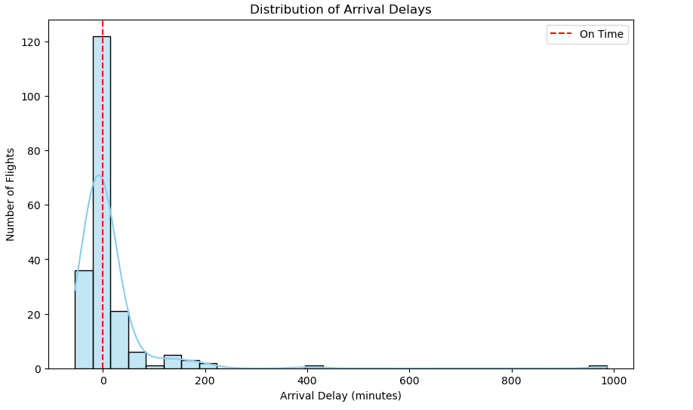

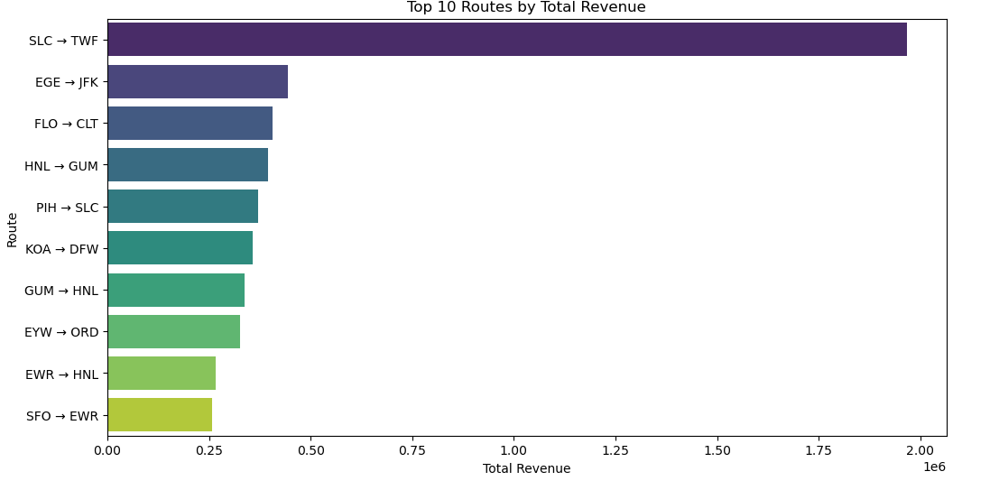

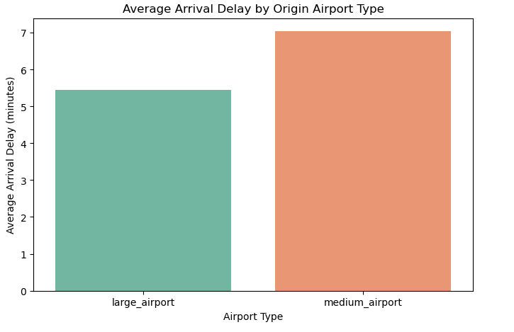

References
1.U.S. passenger carrier delay costs. Airlines For America. (n.d.). https://www.airlines.org/dataset/u-s-passenger-carrier-delay-costs/#:~:text=Delayed%20aircraft%20are%20estimated%20to,productivity%2C%20wages%2C%20and%20goodwill.
2.Guide to Airline Charges and Fees | Alternative Airlines. (2026). Alternativeairlines.com. https://www.alternativeairlines.com/ar/blog/guide-extra-airline-charges
3.Airline Cancellation and Delay Dashboard | US Department of Transportation. (n.d.). Www.transportation.gov. https://www.transportation.gov/airconsumer/airline-cancellation-delay-dashboard
4.National Air and Space Museum. (2025). The Evolution of the Commercial Flying Experience. National Air and Space Museum; Smithsonian. https://airandspace.si.edu/explore/stories/evolution-commercial-flying-experience

